EXERCISE: 14
DATE: 21.11.2020

AIM:
To write a Python class to find validity of a string of parentheses, '(', ')', '{', '}', '[' and '].
PROGRAM:
def areBracketsBalanced(expr):
stack = []
for c in expr:
if c in ["(","{","["]:
stack.append(c)
else:
if not stack:
return False
current_c = stack.pop()
if current_c =="(":
if c!=")":
return False
if current_c == "{":
if c!="}":
return False
if current_c == "[":
if c!="]":
return False
if stack:
return False
return True
if __name__ == "__main__":
expr = input("input:")
if areBracketsBalanced(expr):
print("Output: Valid")
else:
print("Output: Invalid")
LINK:
http://103.53.53.18/mod/vpl/forms/submissionview.php?id=327&userid=1746
OUTPUT:
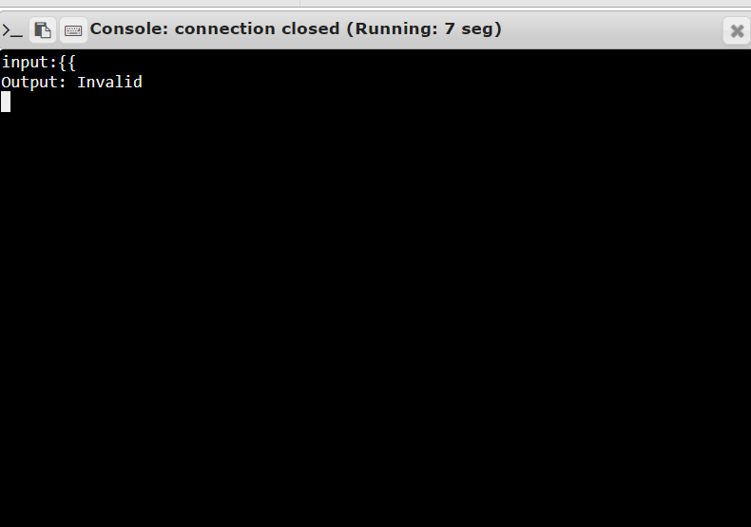
RESULT:
The validity of a string of parentheses is successfully verified.

